Name:________________________ Period/Day:_______ Date:__________

Boating Safety Education Study Guide

Instructions: Use your PA Boating Handbook to complete questions.
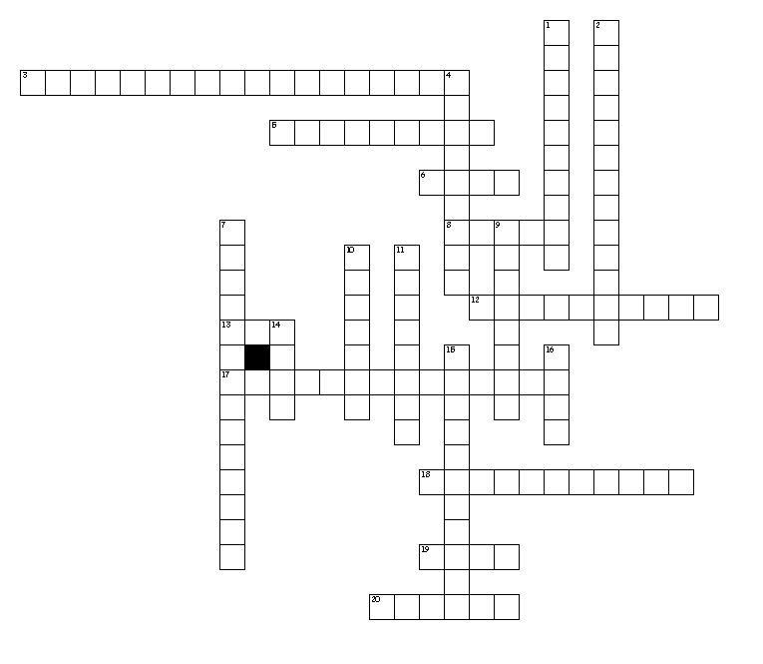

Across
3. If a motorboat is overtaking (passing) a personal watercraft; which one is considered the “stand-on vessel?” (2 words) _____________
5. Straight-ahead to the _________ side - is a boat operator's danger zone.
6. Fire extinguishers should be mounted in an accessible area ________ from the fuel source.
8. Gasoline fumes are most likely to accumulate in the _________?
12. Motorboats and boats powered by electric motors must be _________
13. It is a requirement that a PFD must _____ the person wearing it.
17. Keep air moving through your boat to prevent against ___________ ___________ poisoning. (2 words)
18. Type B fire extinguishers put out which type of fire? (2 words)____________ ______________
19. A give-way vessel's responsibility is to _______ or slow-down and pass astern of the stand-on vessel.
20. In PA, it is required that boats carry one wearable life jacket for each __________ onboard.

Down
1. Anyone being towed behind a boat must wear a ________ ___________(2 words)
2. Maximum weight capacity of persons, motor, and gear are found on the ______________ ___________ (2 words)
4. Boats 16-feet or over in length except canoes and kayaks must carry this type of PFD, _____________________
7. “____________ Density” is the best factor to determine safe boat speed. (2 words)
9. Only when boating on _________ ________ are visual distress signals required to be carried on board. (2 words)
10. Most boating explosions occur from improper ___________.
11. Who should know where to find all safety equipment on your boat? _________________
14. According to the rules of the road, when 2 boats are meeting in a head-on situation, both boats must _________ to starboard.
15. How long should your boat's bilge blower run before starting your gasoline engine? (2 words)___ _______________
16. A PFD must be replaced if it has a ____________ anywhere in the material.

Completion Questions

- What is the most important piece of equipment on a boat? ___________________

At which part of a fire should you aim when using a fire extinguisher? ________________

Each operator of a boat involved in a boating accident must ____________, ____________ _____________, and offer _________________________.

When must a boating accident report form be completed and sent to the PA Fish and Boat Commission? List 2 reasons. ______________________________________________________________________________________________________________________________________

Is it legal to operate a PWC in PA between the hours of sunset and sunrise? (Yes or No)

What does a diver down flag indicate AND describe what it looks like.

Personal watercraft operators in PA must be at least ___________ years old.

What action usually eliminates the ability to steer a PWC?

A ___________________ _________________ is a person who has the ability to assess when a skier is in trouble, knows and understands the water-skiing hand signals, and is capable of helping a skier.

Boats must operate at slow no-wake speed when they are within how many feet of the shoreline, floats, docks, launch ramps, swimmers, downed skiers, and anchored, moored or drifting boats and floats? __________________________

When must navigation lights be displayed? ______________________________________________________________________________________________________________________________________

After sunset, which light must all boats display when at anchor?

______________________________________________________________

Draw the buoys that represent:
*BOATS KEEP OUT! | DANGER! | *CONTROLLED AREA! | INFORMATION!

- What should you do with a float plan you prepared before leaving on a boating trip? _______________________________________________.

- The golden rule if a boat capsizes is to ______________________________________.

- The major contributing factor to boating fatalities is __________________ & ___________________________. Avoid ____________________ in small open boats.

- From which part of the boat should the anchor be lowered? ______________________.

- WATER HAZARDS. The power of __________________ is very __________________ and should be taken into account by all boaters.

- What is the most dangerous hazard on a river? __________________________________.

- The hazards from a low-head dam exist from ___________________________________________________________________.

- List four signs that dangerous weather may be approaching.

  - _________________________________________________________________
  - _________________________________________________________________
  - _________________________________________________________________
  - _________________________________________________________________

- If a storm is near and you are in a small boat, you should…
_____________________________________________________________________.

- What is the first thing you should do if someone falls overboard?
  - Jump in to save the person.
  - Go to shore to get help.
  - Reach to the person with something.
  - Call 911 or contact the Coast Guard.

- Define hypothermia.
________________________________________________________

- List/describe the First Aid Treatment for hypothermia.
  - _________________________________________________________________
  - _________________________________________________________________
  - _________________________________________________________________
  - _________________________________________________________________


26. The letters, H.E.L.P. mean:

- True or False. Alcohol is prohibited on land and water at ALL state parks.

- True or False. An officer can stop a boat and arrest the operator for being under the influence.

- Littering and pollution in the water is unlawful. What must you do if you or one of your passengers’ drops something into the water?

- What is the best way to stop the spread of Aquatic Nuisance Species?

